Name of Employee: Click or tap here to enter text.
Name of Head of department/manager: Click or tap here to enter text.
Date of dialogue: Click or tap here to enter text.
RAL period: Click or tap here to enter text.

Before the annual salary review, you and your head of department/manager will have a salary discussion based on this template, where you document the conversation. It is important that you know on what grounds your salary is set and what you can do to influence your salary. The purpose of the salary dialogue is that you and your head of department/manager together start from the salary criteria and have a dialogue on how it has gone over the past year, evaluate performance and provide and receive feedback. You will also follow up on previous year’s employee talks.
The head of department/manager is responsible for documenting the conversation and the employee receives a copy of the documentation.
The picture below shows what affects the salary. Mid Sweden University has salary criteria that apply to all employees and heads of department/managers.
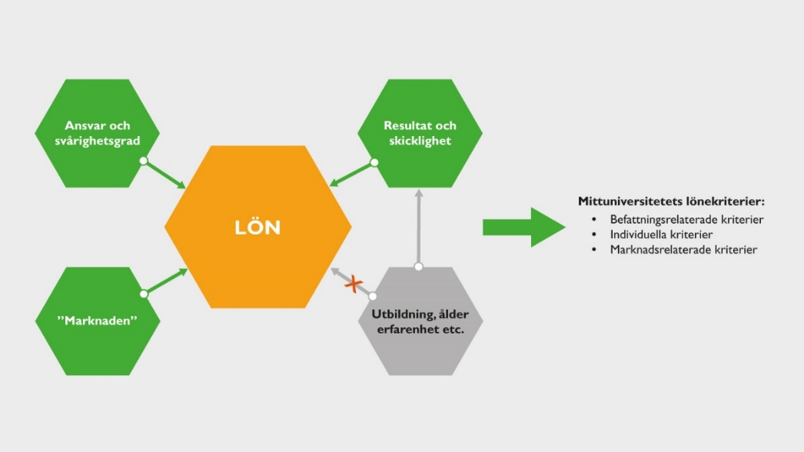

Follow-up of previous year’s performance review
How has it been since the last performance review?
What is the status of the activities in your individual development plan?
Date of previous year’s performance review: Click or tap here to enter text.
Notes:

Individual salary criteria
Individual salary criteria relate to your contribution to the activity. Head of department/manager and employee have a dialogue on how you experience how well the employee meets the individual salary criteria. It is important that the head of department/manager takes note of what you've talked about. It is particularly important if you have different views on how well the salary criteria have been met.
The following individual salary criteria apply to all employees and heads of department/managers at Mid Sweden University:
- Active employeeship
- Results
- Cooperation

Active employeeship:
Take responsibility for tasks by contributing to the development of the business, delivering with quality and on time and being responsible for personal competence development. See what needs to be done and do it. Take responsibility for colleagues and work environment by cooperating, providing support and feedback in a constructive way, and taking responsibility for the employer and the business’s goals and results by seeing their part in the business as a whole.
Develop the business through innovation and problem-solving, monitor the world to change and develop operations and assignments.
The Prefect’s/Head’s and employee’s opinion on how the salary criteria have been met:

Results:
Individual performance to achieve results in accordance with set operational objectives;
Examples for researchers and teachers: Successful teaching work that is assessed through the results of pedagogical skills, involvement in educational planning, administration and pedagogical development work. This may include developing courses, developing pedagogy and contributing to colleagues
Successful research work that is assessed through, among other things, the existence of national and international publication in reputable journals, scientific conferences, to contribute to arranging national and international conferences, assignments in research organisations, application for research funding and supervision of doctoral students.
Successful supervision in postgraduate studies leading to licentiate or doctoral degrees. Contribute to a good working environment for doctoral students and ensure that the doctoral student is ready in time and of good quality in his/her research work.
Examples for TA staff: Proactive and responsive support to the activities by providing support so that the activity can act in line with the applicable regulatory framework and legislation. Deliver assignments according to set goals and on time. Develop support processes to make them efficient and easy to use for the business.
Examples for Heads/Managers with HR responsibilities: Lead and control to effectively achieve set goals, which includes the ability to organise the work, delegate and follow up, and the ability to communicate and conduct dialogue. A head of department/manager shall work for active employeeship and ensure a good working environment. The managerial role includes meeting the requirements for equal opportunities in employment and under discrimination legislation.
Act as employers’ representatives and lead by seeing the whole, standing up for the joint mission and having the ability to lead in change.
The Prefect’s/Head’s and employee’s opinion on how the salary criteria have been met:

Collaboration:
Ability to interact within and outside the department/institution, within and outside your own subject and between campus locations.
Collaborate through contacts with industry and other actors outside Mid Sweden University.
Represent and work to strengthen the image of Mid Sweden University as an attractive employer in various forums.
Work for integrated internationalization, a commitment to actively introduce international and comparative perspectives into all academic training, research, and collaboration.
Examples for researchers and teachers: Active participation both within the department/department and at Mid Sweden University in general, for example through participation in various boards, councils or other internal bodies.
Scope of assignments within agencies such as expert, faculty soup, member of the grading committee at public defence or other assignments.
The Prefect’s/Head’s and employee’s opinion on how the salary criteria have been met:

Position-related salary criteria
Position-related salary criteria are about how much responsibility you as an employee have and take and the difficulty of your work.
Talk about any changes in your duties that have affected the content of your work and the responsibilities you have.
Notes:

Market-related salary criteria
It is not only your duties and results that affect your salary. Factors such as labour supply and demand in the labour market in many cases have an impact on wages.

