Support material for performance reviews
Name of employee: Click or tap here to enter text.
Name of head of department/manager: Click or tap here to enter text.
Date of dialogue: Click or tap here to enter text.
You and your head of department/manager have continuous dialogue day-to-day dialogue all year round. In addition, you have an in-depth dialogue twice a year, the performance review in the spring and the salary review in the autumn. The dialogue creates several positive effects and therefore it is important that both you and your head of department take responsibility and prioritize these meetings. The dialogue gives you the opportunity to take responsibility and focus on your development that creates results forward — both individually for you, your insitition/department and for the entire Mid Sweden University. In addition, the dialogue is an important tool for your head of department/manager to be able to investigate and follow up your work environment. Here it is important that you contribute. Mid Sweden University’s strategy and business plan are important starting points for your dialogue.
All employees have performance reviews that take place during February to April. Then you and your head of department/manager have a dialogue to enable you to:
- be an active employee
- create the conditions for a good working environment
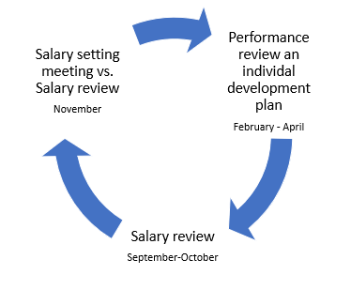
- contribute to the university´s activities in the best possible way
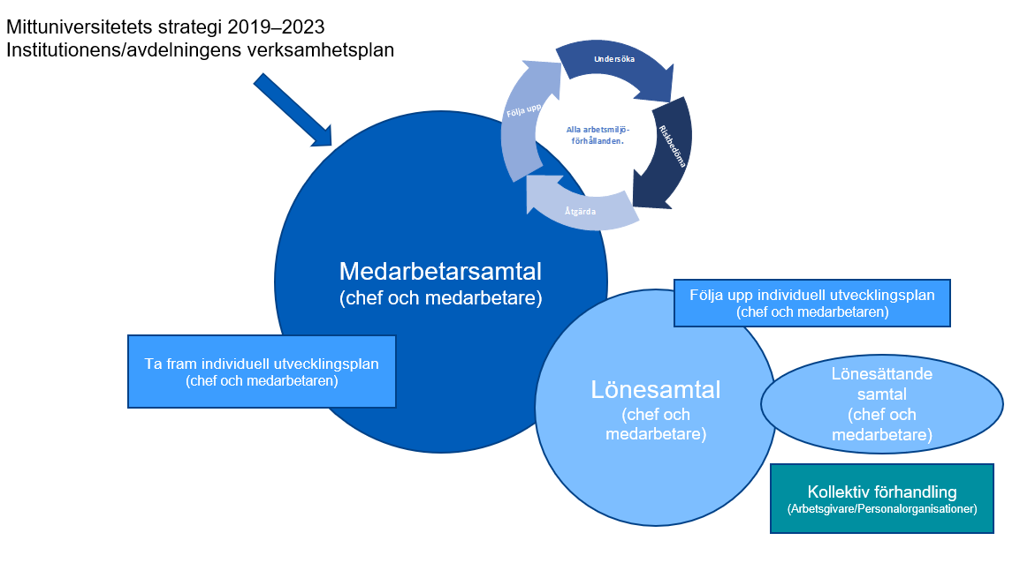
At the performance review, you and your head of department/manager jointly develop some development areas that you document in your individual development plan.
At the salary review meeting in the august to october, the head of department/manager and the employee follow up and review the results of the development areas in the individual development plan.
Dialogue areas at the performance review
Work environment and work balance
- How do you experience the physical work environment? How do you contribute and what support do you need from your head of department/manager?
- How do you experience the social work environment? How does the collaboration work, do you get the support you need? Do you need any support from your head of department/manager?
- How do you experience the digital work environment, e.g. systems and equipment?
- How do you experience the organisational work environment, i.e. the balance between the requirements that exist for you (what, how and when the work is to be carried out) and the resources available (technology, staffing and time)? What does the workload look like? Do you see any need for changes linked to this?
- Have you experienced that you have been harassed or sexually harassed? Have you experienced that you have been discriminated based on gender, transgender identity or expression, ethnicity, religion or other beliefs, disability, sexual orientation or age?
- Do you see any risks in the physical or social work environment that could lead to discrimination (or create other barriers to access to equal rights or opportunities)? If yes, describe the risk or obstacles you see. (relevant working conditions, wages and conditions of employment, recruitment and promotion, training and other skills development or the possibility to reconcile work and parenthood)
- Have you experienced that you have been subjected to offensive discrimination* or bullying at your workplace?
* Offensive discrimination means “Documents directed at one or more workers in an offensive manner and which may lead to ill-health or put them outside the community of the workplace”. Read more in Mid Sweden University’s guidelines and procedures against abusive discrimination.

Notes:

Your contribution to the university´s activities and your development
- What kind of competence enhancement and support do you need to succeed in your work to contribute to the institution/department?
- What kind of leadership do you need to have the right conditions to do a good job? What has been good and what could be improved?

The following questions are connected with Mid Sweden University’s individual salary criteria:
- How can you develop your active employeeship?
- How well would you say you present practical results in terms of your tasks and assignments?
- In what contexts do you currently cooperate with other people? How can you further develop your cooperations?
- If you have a leadership role today, is it functional? How can you develop your leadership?

Other issues
Anything else you would like to discuss?
Notes:

Closure
Head of department/manager informs the employee about the rules for secondary activities that apply to employees at Mid Sweden University. Any secondary activities are recorded in Primula (read more on the employee portal).

Individual development plan
Date: Click or tap here to enter text.
Name of employee: Click or tap here to enter text.
Name of head of department/manager: Click or tap here to enter text.
Place of work: Click or tap here to enter text.

Jointly prioritize some development areas during the year based on the completed employee discussion and note in this plan.
During the salary conversation, you should have dialogue and follow up on how the different activities have gone.
Area of development | How will the development take place? | When (timetable)

Individual action plan based on health and safety
Date: Click or tap here to enter text.
Name of employee: Click or tap here to enter text.
Name of head of department/manager: Click or tap here to enter text.
Place of work: Click or tap here to enter text.
If you identify risks in the work environment that may lead to ill-health or accidents in the context of OSH issues, these will need to be assessed, addressed, and followed up. Risk assessment is carried out with ‘low, medium or high’ risk. An action plan shall also be drawn up on actions which are not implemented at once.
Description of risk | Low, medium or high risk? | Action | Responsible for the action | Clear date

Mid Sweden University’s salary criteria

Individual salary criteria
Individual criteria refer to the employee and his/her contribution to the activity.

Active employeeship
Take responsibility for tasks by contributing to the development of the business, delivering with quality and on time and being responsible for personal competence development. See what needs to be done and do it. Take responsibility for colleagues and the work environment by cooperating, providing support and feedback in a constructive way, and taking responsibility for the employer and the business’s goals and results by seeing their part in the business as a whole.
Develop the business through innovation and problem-solving, monitor the world to change and develop operations and assignments.

Results
Individual performance to achieve results in accordance with set operational objectives;
Examples for researchers and teachers: Successful teaching work that is assessed through the results of pedagogical skills, involvement in educational planning, administration and pedagogical development work. Examples include developing courses, developing pedagogy and contributing to colleagues in the teaching team.
Successful research work that is assessed through, among other things, the existence of national and international publication in reputable journals, scientific conferences, contribute to arranging national and international conferences, assignments in research organisations, application for research funding and supervision of doctoral students.
Successful supervision within doctoral studies leading to a licentiate or doctoral degree, such as contributing to a good working environment for doctoral students, ensuring that the doctoral student is ready in time and of good quality in his/her research work.
Examples for TA staff: Proactive and responsive support to the activities by providing support so that the activity can act in line with the applicable regulatory framework and legislation. Deliver assignments according to set goals and on time. In addition, develop support processes to make them efficient and easy to use for the business.
Examples for managers: Lead and control to effectively achieve set goals, which includes the ability to organise the work, delegate and follow up, and the ability to communicate and conduct dialogue. A manager must promote active employeeship and ensure a good working environment. The managerial role includes meeting the requirements for equal opportunities in employment and under the Discrimination Act.
To act as employers’ representative and lead by looking at the whole and standing up for the joint mission and having the ability to lead in change.

Cooperation
Ability to interact within and outside the department/institution, within and outside its own subject and between locations.
Collaborate through contacts with industry and other actors outside Mid Sweden University.
Represent and work to strengthen the image of Mid Sweden University as an attractive employer in various forums.
Examples for researchers and teachers: Active participation both within the department and at Mid Sweden University in general, for example through participation in various boards, councils or other internal bodies.
Scope of assignments within agencies such as expert, faculty soup, member of the grading committee at public defence or other assignments.

Position-related salary criteria
Position-related criteria refer to the level of responsibility of the employee in their work and the difficulty of the work.

Level of difficulty and job content
‘Severity’ means the knowledge, qualification, experience and ability required to perform the duties in the position.

Responsibilities at work
This refers to the level of responsibility in the context of the position.

Market-related salary criteria
Market-related salary criteria is about supply and demand in terms of staff members. It is not only the tasks and an employee´s results that affect the salary. Things like supply and demand on the labour market as well as the general salary situation on the market often have an influence on the salary, too. A market-related salary is what other employers are willing to pay for an employee with a certain competence. An employer has to pay the price needed to ensure that all competences the activities require can be provided. This is the case both forrecruitment and for keeping key competences in the organization.

