Points to remember before the dialogue
Head of department/manager and employee have continuous dialogue in everyday life. In addition, in-depth dialogues take place twice a year. The the performance review in the spring and the salary conversation in the autumn. Mid Sweden University’s strategy and business plan are important starting points for the dialogue between employees and head of department/manager.
The performance review will take place during February to April between prefects/managers and their employees. This is important that both managers and employees prioritise these conversations that are important both for the business needs and for the employee’s development. In addition, the conversations are an important tool for the manager to be able to work with his/her work environment tasks. During the talks there are both examinations, risk assessment, planning of measures and follow-up of the work environment.
During the salary review that take place in the autumn, the individual plan is followed up and the manager and employee have dialogue based on Mid Sweden University’s salary criteria.
The talks require preparation from both head of department/manager and employee. The needs for development and change that are jointly identified are recorded in the individual development plan at the performance review and followed up at the salary review.
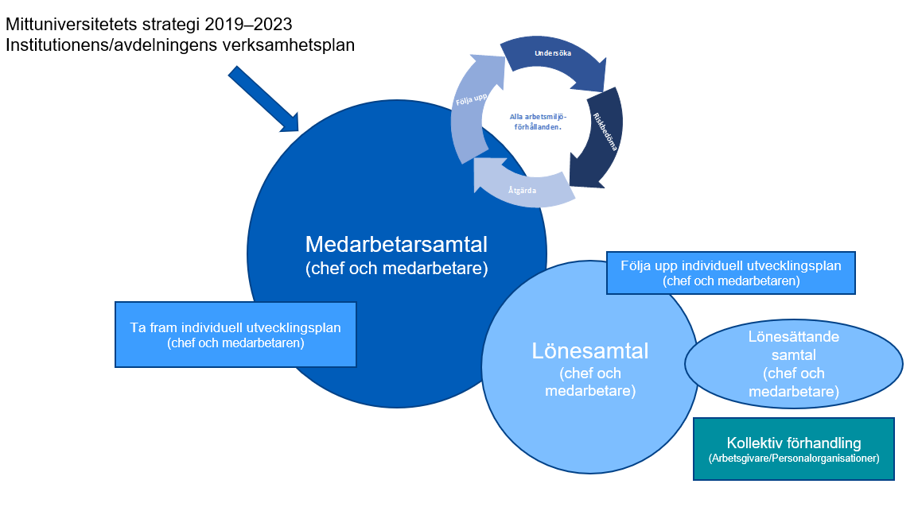
Before the meeting
- Schedule the meeting comfortably in advance and if possible choose an secluded, neutral environment
- There is a template that is used for performance review. You can find these on the “Medarbetarportalen”. Read also at Mid Sweden University’s guidelines against abusive discrimination, discrimination, harassment, sexual harassment and retaliation.
- Head of department/manager and employee read, reflect and make their own notes in “Template for performance review” at the dialogue in spring and in “Template for salary review” at the salary call in the autumn.
- Review your respective minutes of the last conversation
- Use the previous year’s individual development plan and reflect on what activities you have performed or not performed
- Before the salary review, please read up on on Mid Sweden’s salary policy and salary criteria.

During the meeting
- Respect the time set aside for the call. Both manager and employee are responsible for creating an atmosphere that leads to constructive and positive dialogue in trust
- Show interest and commitment, listen actively and ask open questions
- Try to be specific and honest in your praise and constructive in your criticism
- Focus on set-up activities and actions. How have they progressed?
- Remember that the development plan can include activities of a non-academic nature, e.g.. taking on greater responsibility, trainee duties, reading course literature, receiving support from a supervisor and taking part in networks and other forums
- Provide information on the regulatory framework for secondary activities and how to register any secondary activities in Primula
- Both manager and employee will keep notes in their respective templates during the meeting.
- Conclude the conversation by summing up what you have jointly reached

After the meeting
- At the employee discussion, the employee is responsible for documenting in the individual development plan and sending a copy of the plan to his/her manager. It’s good that both have their own copy when it’s time to follow up the plan at the salary review
- At the salary review, the head of department/manager is responsible for documenting and the employee receives a copy of the documentation
- It is both parties’ responsibility to fulfil their part of whatever has been agreed.

